Perspectives in Social and Cultural History: Sport and Spectacle in the Ancient World
Instructor: Joel Allen

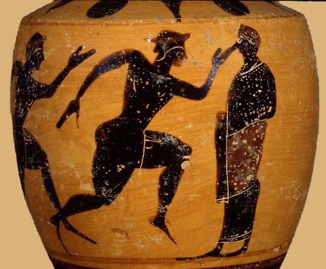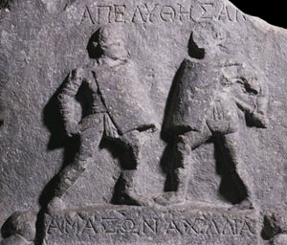

Description

This course explores what we know about athletics and popular entertainment in ancient Greece and Rome and how we know it. Topics include the world of Homeric epic, the Panhellenic sanctuaries, dramatic festivals, funeral games, gladiatorial exhibitions and chariot racing. We will look not only at the logistics of organized competitions (their locations, procedures, and proliferation), but also the changing religious and philosophical aspects of athletics, the social status of the athlete, and the role of public games in society, politics, and international relations. Our evidence will range widely from the literary to the artistic, including epic poetry, lyric odes, comic satires, monumental sculpture, vase paintings, and archaeological sites. A principal part of the class will involve discussion of how such a variety of sources can be used critically and profitably by social and cultural historians.

General Education Requirements: This course meets three General Education Requirements. It meets the “Analyzing Social Structures” Area requirement because it explore the political, economic, and social operations of athletics and entertainment and how they are connected with governments and with the historical development of societies. Because it focuses on ancient Greece and Rome, it fulfills the European Tradition Context of Experience requirement. Because the societies examined were pre-industrial, it meets the Pre-Industrial Extended Requirement.

Readings

- Stephen Miller (ed.), Arete: Greek Sports from Ancient Sources, third edition (University of California Press, 2004)
- Alison Futrell (ed.). A Sourcebook on the Roman Games (Blackwell, 2006)
- Additional readings available in a course packet or on-line through e-reserves.

Assessment

Midterm 25%
Essays (2) 40%
Final 25%
Participation 10%

Exams will be a combination of short answer and essay questions. Make-ups will only be given in the event of unusual circumstances. If you need to schedule a make-up, you MUST notify me BEFORE the date of the exam.

The two essays papers will each have a strict limit of 750 words (about 3-4 pages). You will be asked to answer specific questions in an organized and succinct way. The papers will not require any extra reading beyond what is on the syllabus.

Any indication of academic dishonesty (plagiarism, cheating, forgery, etc.) will result in a zero on the assignment in question and referral to the college authorities.

Schedule

Week 1: Introduction
- CP: selection from Felix Gilbert, History: Politics or Culture? Reflections on Ranke and Burkhardt (Princeton: Princeton University Press, 1992).

Week 2: What is social history? What is cultural history?
- CP: Clifford Geertz, “Thick Description: Toward an Interpretive Theory of Culture” (1973).

Week 3: Prehistoric Greece

1. Bronze Age competitions
- Minoan bullfighting
- Theran boxing

2. Funeral games in the Dark Ages
- Iliad 23.256-897: funeral games of Patroclus
- Odyssey 8.97-384: dinner games of Phaeacians.
- Pausanias 5.17.5-11: funeral games of Pelias, depicted on a chest at Olympia.

Week 4: Olympia and Panhellenism

1. Competition and the rise of the polis
- Pindar, Olympian 10 (29-92)
- Strabo 8.3.30-33
- Phlegon, History of Olympia
- Pausanias 5.7

2. Types and procedures of competitions
- Lucian, Anacharsis
- The Panathenaea

Week 5: Attitudes and values

1. Spectacular genders
- Brauron
- Sparta

2. Philosophers examine athletics
- Plato and Aristotle

Week 6: The politics of prestige

1. Spoils
- The lyric poets: Pindar, Bacchylides, Simonides
- Herodotus and Thucydides

2. Disruption and change
- The Peloponnesian War
- The An-Olympiad of 364 BCE

Week 7: Hellenistic adaptations

1. FIRST ESSAY DUE: Should a modern university fund athletics?

2. Alexander the Great and the eastern world

Week 8: Prehistoric Italy

1. MIDTERM

2. Early Rome
- Ludi and religious festivals
- Munera and Etruscan customs

Week 9: Rites of passage

1. Maturity and marriage

2. Death and burial

Week 10: Greek culture in the Roman world

1. Roman jingoism
- Cato the Elder
- Aemilius Paulus

2. Augustus and the “Century Games”

Week 11: “Fatal charades”

1. The triumphal procession
- Prisoners of war and slavery

2. Crime and punishment

Week 12: Fanaticism and professionalization

1. Social status and the Roman games
- Seneca
- Nero and Commodus

2. Chariot-racing

Week 13: Science and superstition

1. SECOND ESSAY DUE: Should executions be made public?

2. Medical writers on athletics
- Galen, Philostratus, and the Hippocratics
- Curse tablets

Week 14: Christianity and the Roman games

1. Factiones in Late Antiquity
- Procopius and the Nika revolt

2. Paganism’s last stand

FINAL EXAM

