Name: __________________________________ Date Completed: _____________________________
Class: ____________ Lab Minutes: _______________ Teacher: _______________________________

Using a Dichotomous Classification Key to Identify
Common Freshwater Fish of New York State

Special Thanks to Rick Marshall, Massena High School, Massena NY for his contributions to the re-creation of this lab experience.

Background: A dichotomous key is a tool that allows the user to determine the identity of items in the natural world, such as trees, wildflowers, mammals, reptiles, rocks, and fish. Keys consist of a series of “either or” choices that lead the user to the correct name of a given item. "Dichotomous" means "divided into two parts". Therefore, dichotomous keys always give two choices in each step.

Dichotomous keys are extremely important tools in science and even in fields like auto repair and crime investigation. This lab uses the identification of some common types of North American fish as an example of how to use a dichotomous key.

Purpose: The purpose of this laboratory experience is:
-to correctly use a dichotomous key for identifying common freshwater fish found in New York State,
-to understand how scientists in a variety of fields use classification keys to identify specimens.
-to further understand the necessity of the Linnaean classification system
-to correctly identify unknown specimens

Materials: The following materials are needed to complete this laboratory experience:
Lab papers
Pen and pencil
Specimen cards and diagrams

Procedure: The following procedure is utilized to perform this experience:

Study the terms listed below. All of these refer to structures of a fish.

Barbel – a fleshy projection from the lip or head.
FINS
Adipose- a small fin on the top mid-line of the body near the tail fin.
Anal– a fin along the lower mid-line of the body near the tail fin.
Caudal- tail fin.
Dorsal – the fin or fins along the top mid-line of the body.
Pectoral- the paired fins nearest the head, corresponding to front legs or arms.
Pelvic- the paired fins nearest the tail, corresponding to hind legs.
Scales- overlapping outgrowths of the skin.

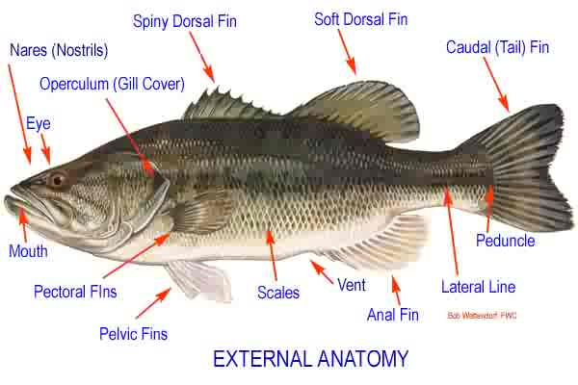

1. Closely examine one of the drawings of a fish shown on the next pages.
2. Read both statements listed under number 1 in the classification key.
One of these statements should describe the fish you have chosen; the other should not.
- Refer to the number after the statement that fits your fish and look for that number in the key.
- Again select the statement that describes the fish you picked. Continue through the key until you come to a name after one statement. This should be the name of the fish you picked.
- Practice using the key to identify several of the fish shown

Example:
Suppose you want to find the name of fish 2. Look at the classification key. Note that each numbered item presents two possibilities. We see that our fish has no scales, or at least we cannot see any. So we choose item lb. This refers us to number 12. So we go down the page to number 12. Our fish is not elongated or snakelike (item 12b), so we go to number 13 of the key. The fish we are classifying has barbels growing from its lips and the top of its head (item 3a), so we go to number 14 of the key. Since our fish has a caudal fin that is rounded, and a blunt head, we see that it is the Bullhead catfish.

Classification Key for Common Freshwater Fish of New York State

Questions | Identify/Go To
1a. Body noticeably covered with scales | 2
1b. Scales not covering body or too small to be seen | 12
2a. Dorsal fin single | 3
2b. Dorsal fins two or more, joined or separated | 6
3a. Body more than four times as long as broad (top to bottom): front edge of dorsal fin far back on  body;mouth large, hinge back of eye | 4
3b. Body less than four times as long as broad: front edge of dorsal fin about midway between head  and tail; mouth not large, hinge in front of eye | 5
4a. Dark lines forming netted design on body: fins not spotted | Pickerel
4b. Body covered with yellow spots; fins spotted | Northern Pike
5a. Mouth turned downward: barbels absent; dorsal fin not elongated | White Sucker
5b. Mouth not turned downward: barbels present; dorsal fin elongated | Carp
6a. Two dorsal fins separated, the anterior spiny and the posterior soft | 7
6b. Two dorsal fins united, forming an anterior spiny portion and a posterior soft portion | 8
7a. Top of head concave, farming a hump in front of dorsal fin; dark vertical bars on body | Yellow Perch
7b. Top of head not concave, body sloping to dorsal fin and not forming a hump; dark blotches on body | Walleye
8a. Body more than three times as long as broad | 9
8b. Body less than three times as long as broad | 10
9a. Hinge of jaws behind the eye: notch between spiny and soft dorsal fin deep and nearly separating into two fins | Large Mouthed bass
9b. Hinge of jaws below the eye; notch between spiny and soft dorsal fin not nearly separating into two fins | Small Mouthed Bass
10a. Mouth large, hinge below or behind eye | 11
10b. Mouth small, hinge in front of eye | Bluegill
11a. Five to seven spines in dorsal fin; dark spots forming broad vertical bars on sides, Red/orange earspot on gill covering | Pumpkinseed
11b. Ten or more spines in dorsal fin: sides flecked with dark spots | Rock Bass
12a. Body much elongated and snakelike: dorsal, caudal, and anal fins continuous | American Eel
12b. Body not elongated and snakelike: dorsal, caudal, and anal fins separate; adipose fin present | 13
13a. Barbels growing from lips arid top of head; head large and broad | 14
13b. Barbels lacking; head not large and broad | 16
14a. Caudal fin deeply forked; head tapering | 15
14b. Caudal fin rounded or slightly indented but not forked: head blunt | Bullhead
15a. Dorsal fin rounded at top: body silvery, speckled with black markings | Channel Catfish
15b. Dorsal fin long and pointed at too: body bluish-gray without speckles | Blue Catfish
16a. Caudal fin deeply forked: back not mottled and with few spots | Atlantic Salmon
16b. Caudal fin square or slightly indented; back mottled or spotted | 17
17a. Back and caudal fin spotted: broad horizontal band along sides | Rainbow Trout
17b. Back mottled with dark lines: caudal fin not spotted; fins edged with White | Brook Trout

Data: The following data was collected during this experience:

Fish # | Identified as | Identification pathway
1
2
3
4
5
6
7
8
9
10
11
12
13
14
15
16
17
18

Conclusion Questions: The following can be concluded from performing this lab experience:

1. What did you learn to do?

________________________________________________________________________________________________________________________________________________________________________________________________________________________________________________________________________________________________

2. What type of career would you expect to use this activity in? What would you be doing in this career and what sort of benefit would making a key have?

________________________________________________________________________________________________________________________________________________________________________________________________________________________________________________________________________________________________

3. What was the most difficult part of developing your classification key?

________________________________________________________________________________________________________________________________________________________________________________________________________________________________________________________________________________________________

Analysis Questions: There are no specific analysis questions for this experience. You must identify each of the specimens by their Common and Scientific names in the table below. You will need to resource this using the internet or other resources.

Fish # | Common Name | Scientific Name
1
2
3
4
5
6
7
8
9
10
11
12
13
14
15
16
17
18

General Fish Anatomy

Fish 1
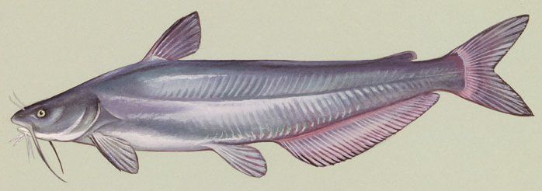

Fish 2

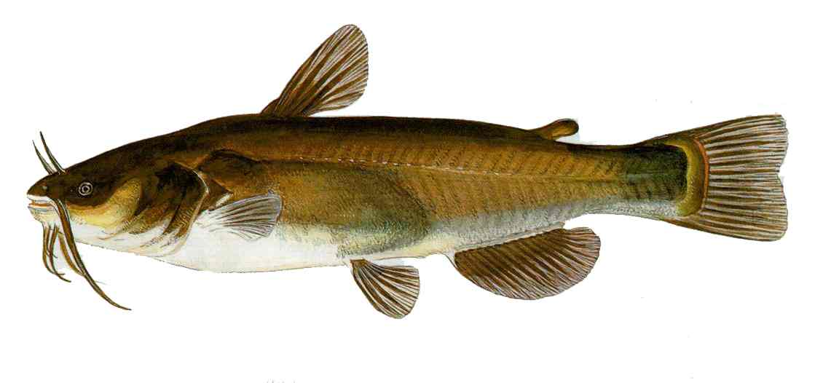

Fish 3
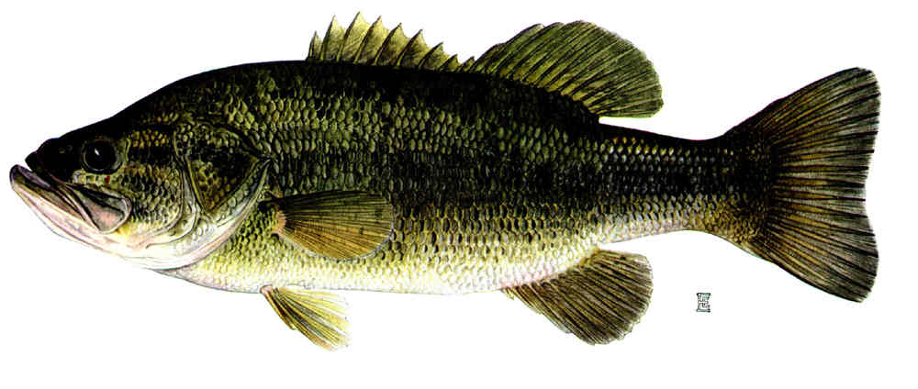

Fish 4
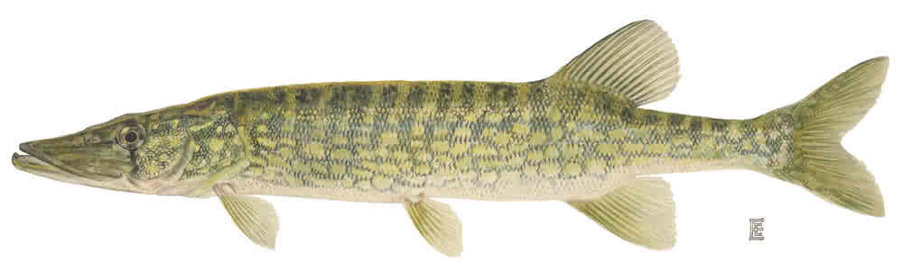

Fish 5
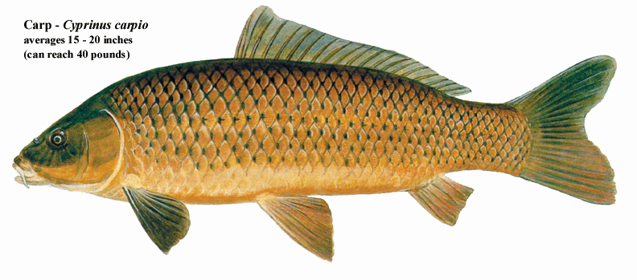

Fish 6
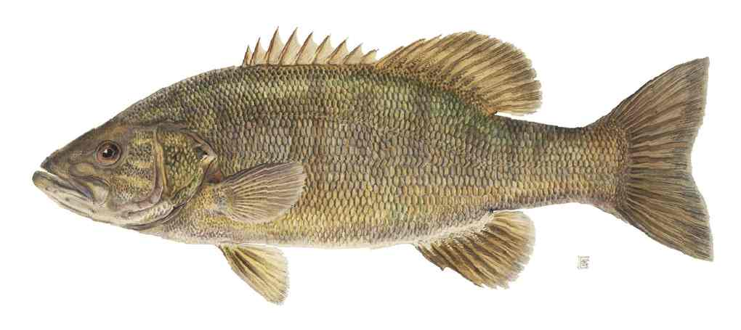

Fish 7
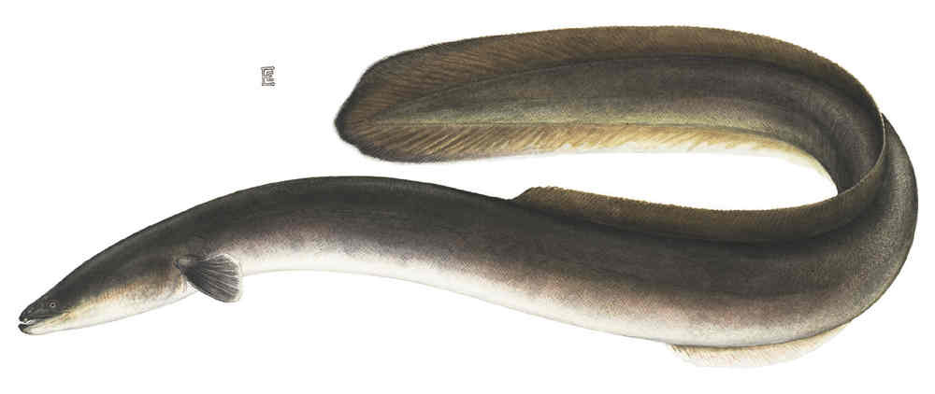

Fish 8
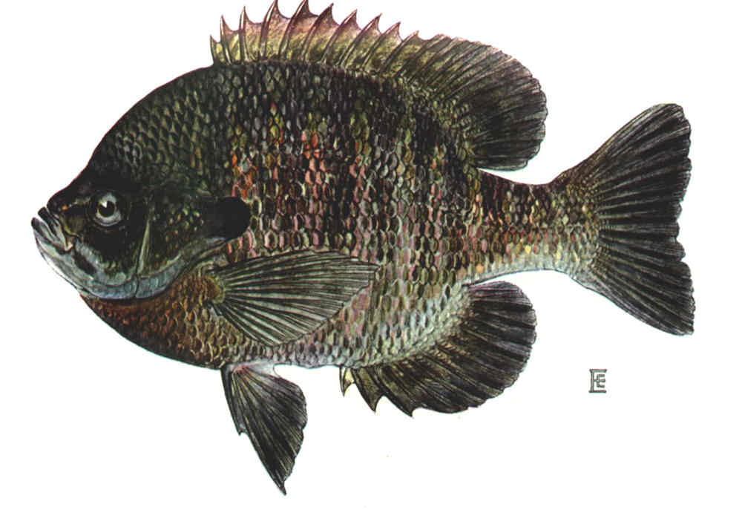

Fish 9

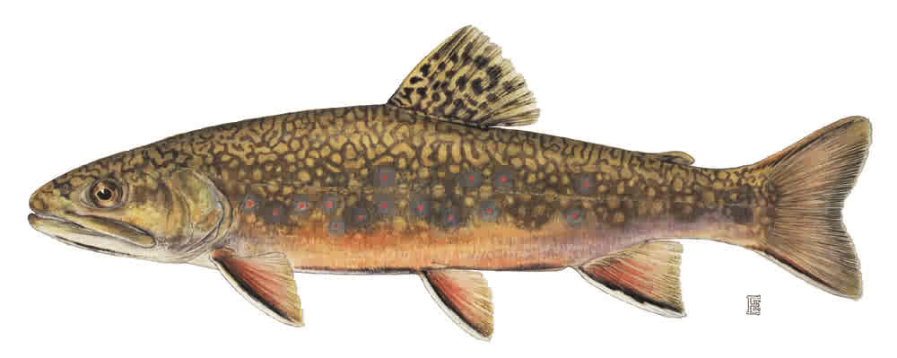

Fish 10

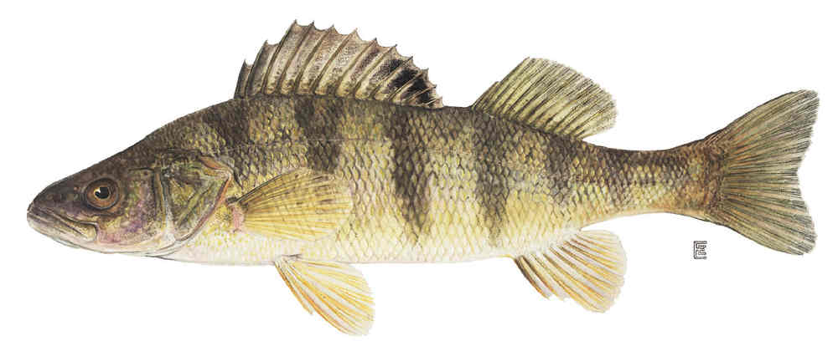

Fish 11
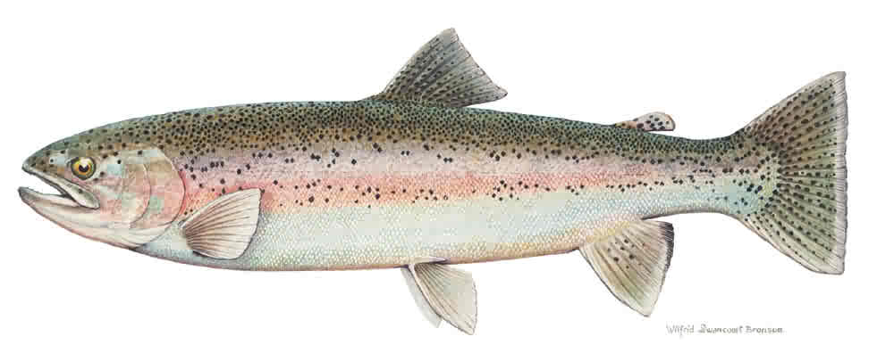

Fish 12
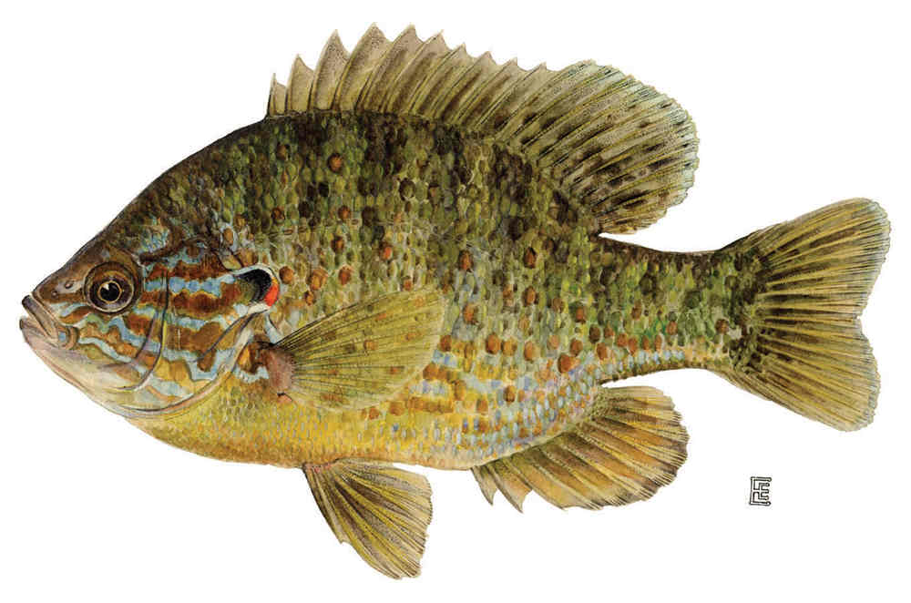

Fish 13
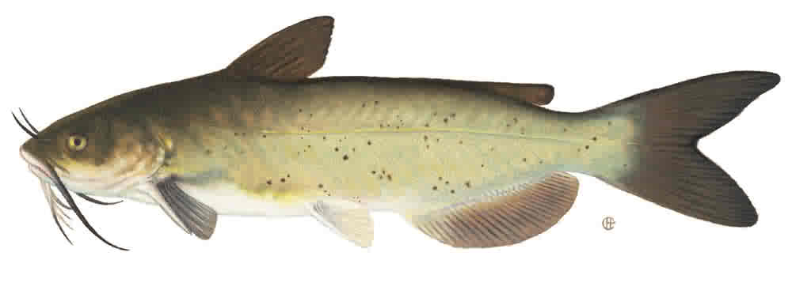

Fish 14
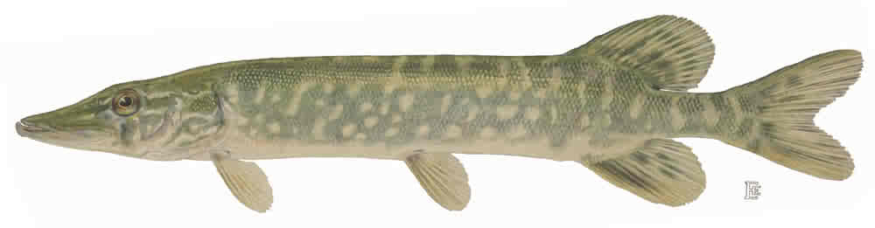

Fish 15
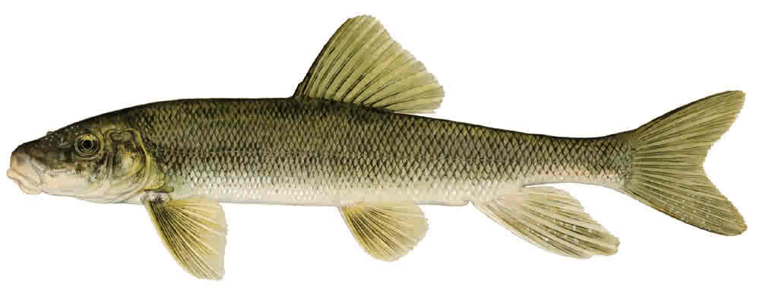

Fish 16
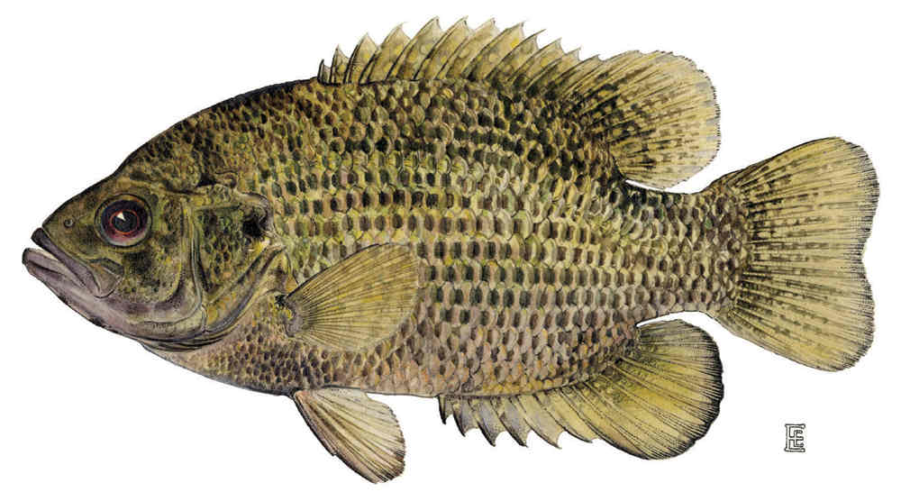

Fish 17
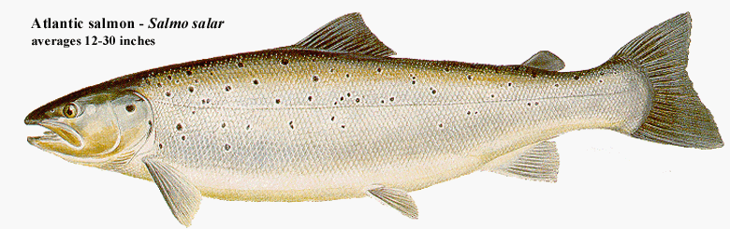

Fish 18


